**Assignment-4**

**Aitik Gupta**

**2018IMT-010**

Course – ML Lab (ITIT 4103)

Deadline – 18th October 2021

Code Link: <https://github.com/aitikgupta/ITIT-4103-2021/tree/main/Assignment 4>

Equations:

* Mean Squared Error:

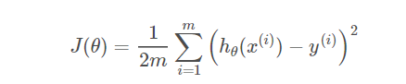

* Linear Regression model:

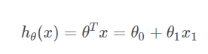

* Gradient Descent:

Results:

learning_rate: 0.001  
Hypothesis Function: h(x) = 0.01 + 0.8x1

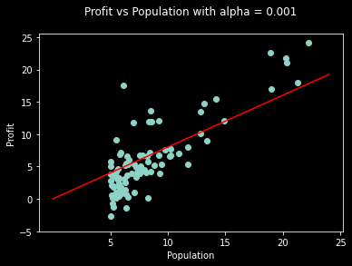

learning_rate: 0.003

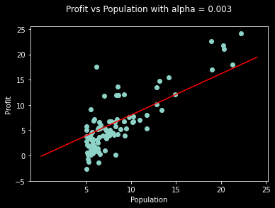Hypothesis Function: h(x) = -0.13 + 0.81x1

learning_rate: 0.005

Hypothesis Function: h(x) = -0.26 + 0.83x1

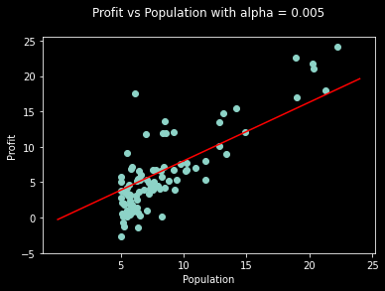

learning_rate: 0.011

Hypothesis Function: h(x) = -0.64 + 0.87x

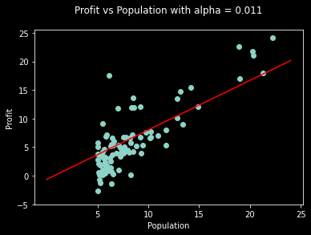

learning_rate: 0.019

Hypothesis Function: h(x) = -1.07 + 0.91x1

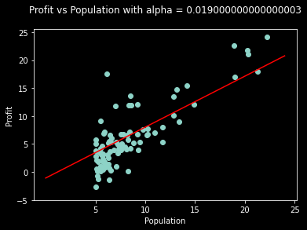

**Cumulative Result:**

x == cost function value  
y == learning rates  
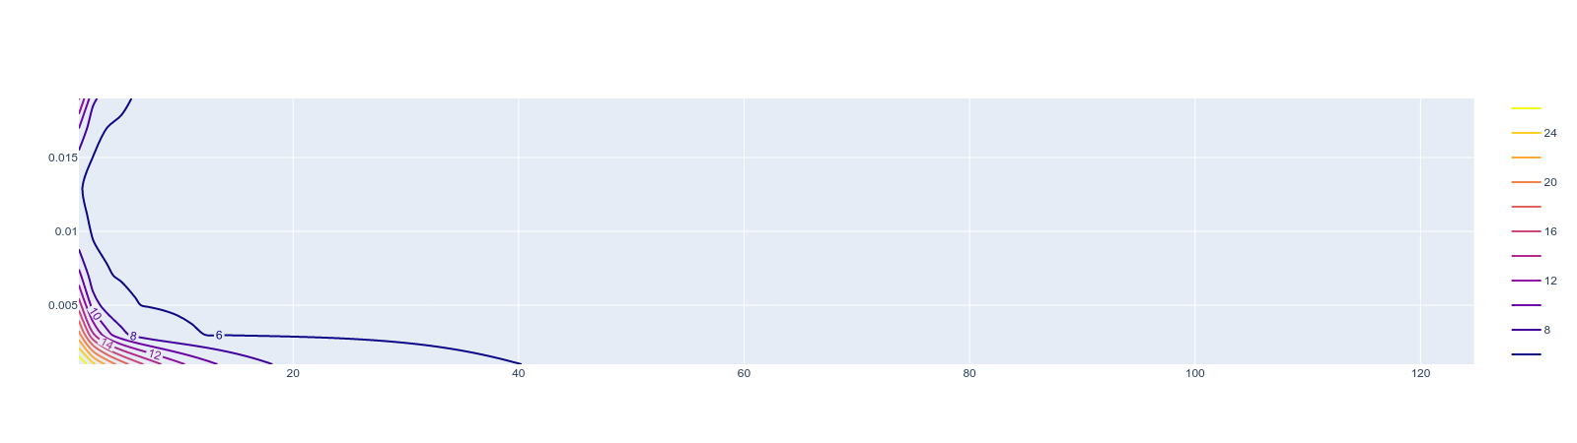z == cost function value at a given learning rateIf slope:

**Inference:**

If slope:

* is +ve: θj = θj – (+ve value). => θj decreases.
* is -ve: θj = θj – (-ve value). => θj increases.

Correct learning rate is important as it ensures that Gradient Descent converges (in a reasonable time):

* If α is very large, Gradient Descent can overshoot the minimum at every minimisation step. It may fail to converge and can even diverge.
* If α if very small, Gradient Descent will take infinitely small steps. (it would reach local minima but will take a very long time)